**“Flight of the Condor”**

**Engineering and Design Challenge**

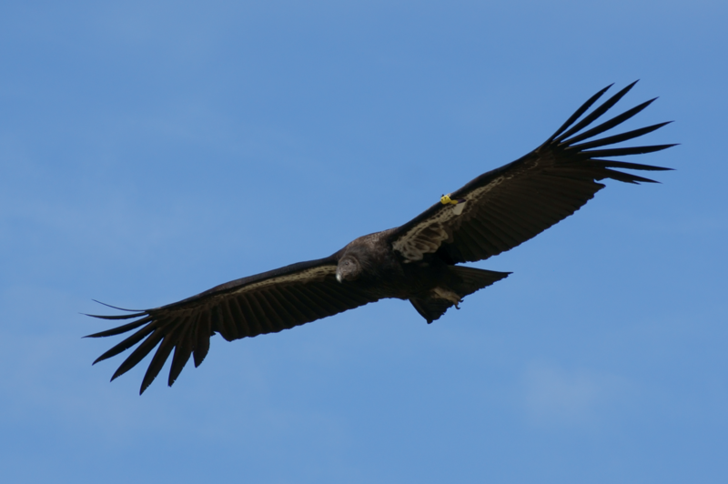

Introduction: Many birds save energy by utilizing updrafts of air caused by wind, physical obstructions, or thermally to glide effortlessly through the sky. This is usually seen in large birds where constant powered flight would require a high amount of energy and be physically taxing.



Problem: Students will work alone or with ONE partner to design a “flying wing” that will soar on an updraft caused by pushing a piece of plastic or cardboard at an angle just behind the “wing”. Before construction, students may research possible designs and make a neatly drawn plan of their “wing”. The students will be evaluated based on the neatness of their initial and final design drawings and the flying ability of their “wing”.

Limitations:

~The “wing” must not be self-powered

~The “wing” may not come into contact with the plastic or cardboard pushing surface during flight

~Students will be allowed to practice flying for no less than 5 minutes before their assessment

~Students will be allowed only ONE assessment opportunity per height challenge

~Once failing a height challenge, students will be eliminated from further competition

Evaluation Criteria: The following breakdown will be used to assess student performance on this project. Scores will be input under the “formative assessment” category.

5 points for neatly drawn initial design

5 points for neatly drawn final design

10 points for detailed written conclusion/summary

10 points for “wing” flying from starting line to target

5 points for successfully piloting “wing” between uprights and over 60 inch barrier

5 points for successfully piloting “wing” between uprights and over 70 inch barrier

5 points for successfully piloting “wing” between uprights and over 80 inch barrier

5 points for successfully piloting “wing” between uprights and over 90 inch barrier

50 POINTS TOTAL POSSIBLE

NAME(S):__________________________________________________PERIOD:_____

**TOTAL SCORE = ____/50**

**Initial design sketch** *(5 points)*

**Final design sketch** *(5 points)*

**Flight Assessment**

|  |  |
| --- | --- |
| **Challenge** | **Points Earned** |
| *Able to Fly* | **/10** |
| *60 centimeters* | **/5** |
| *70 centimeters* | **/5** |
| *80 centimeters* | **/5** |
| *90 centimeters* | **/5** |
| **TOTAL** | **_____/30** |

**Conclusion**

Summarize in 2-3 paragraphs what challenges you faced during this project, what you did to overcome those challenges, what you would do (if anything) differently next time, and what you learned from this experience. *(10 points)*